**Assignment 09**

1. Consider each document in the zipcode collection has the following form:

{

"_id": "10180",

"city": "NEW YORK",

"state": "NY", "pop": 5574,

}

Return States with Populations above 10 Million

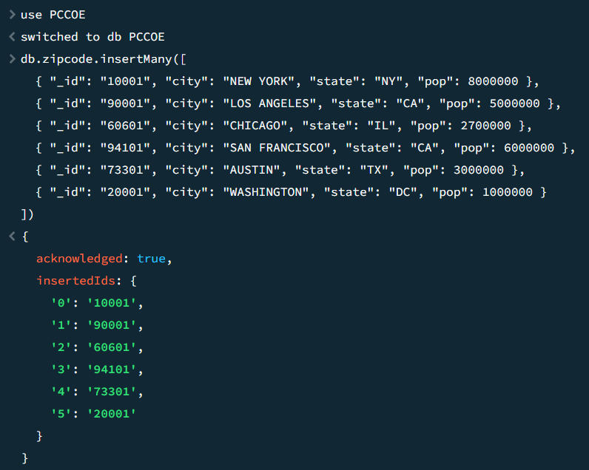

* **Insert sample data into Teachers collection**

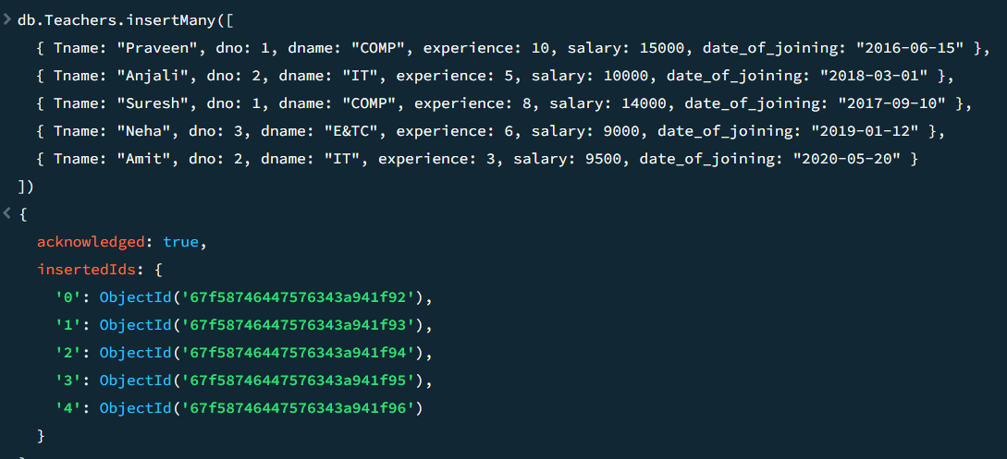

* **Insert data in Students collection**

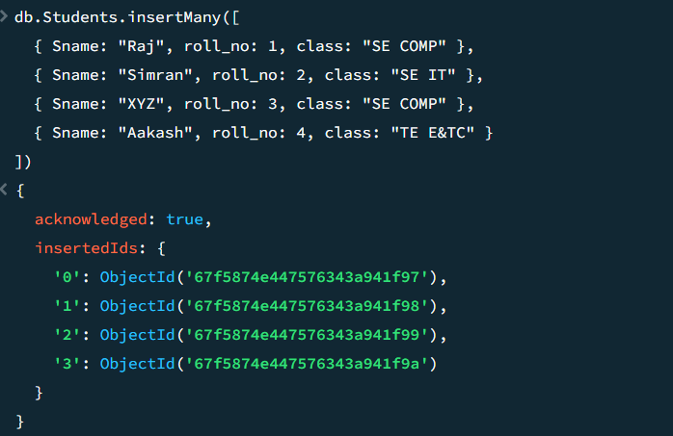

**Questions:**

1. Return States with Populations above 10 Million

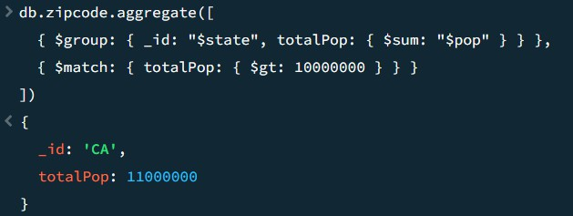

1. Display the department wise average salary

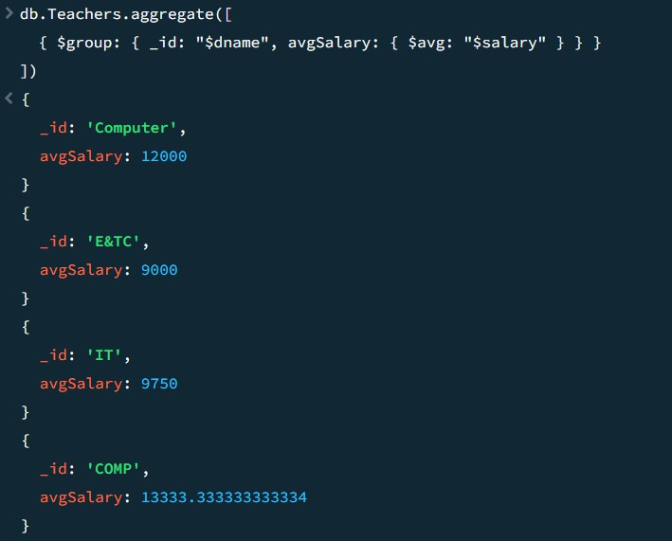

1. display the no. Of employees working in each department

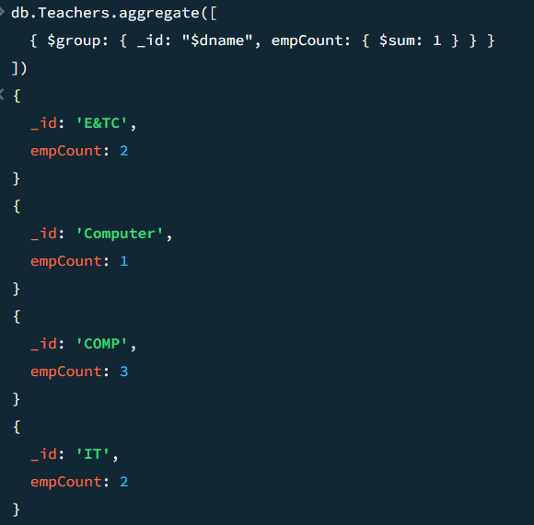

1. Display the department wise total salary of departments having total salary greater than or equals to

5000/-

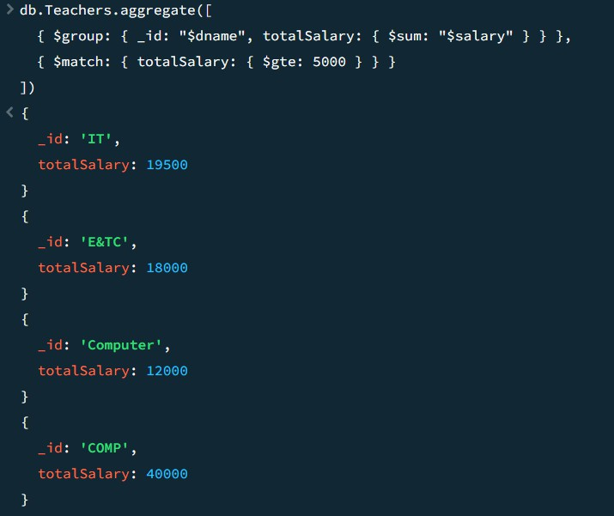

1. Write the queries using the different operators like max, min. Etc.

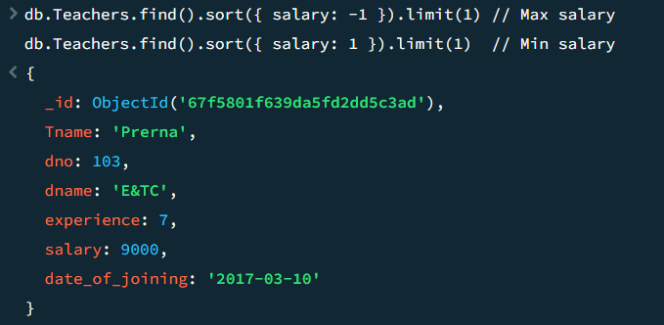

1. Create the simple index on roll_no field

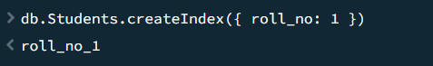

1. create unique index on any field for above given collections



1. create compound index on any fields for above given collections



1. Show all the indexes created in the database PCCOE

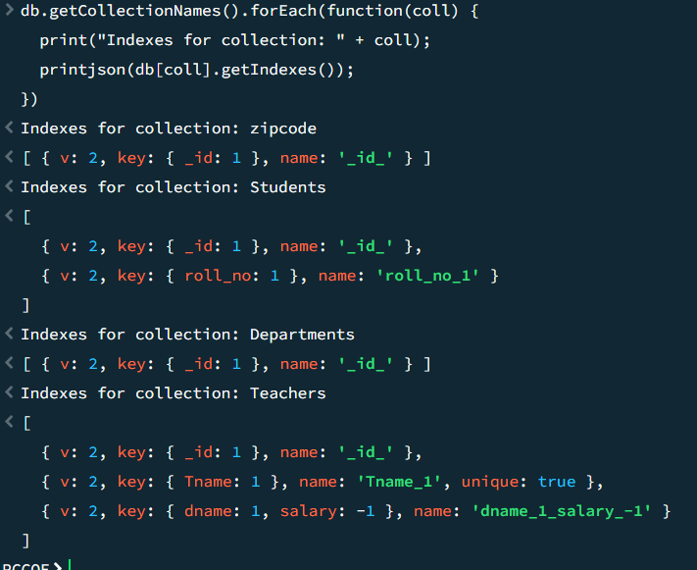

1. Show all the indexes created in above collections.

